LED DISTANCE INDICATOR

AIM : In this project distance measurement of an obstacle by using ultrasonic sensor .

INTRODUCTION : It is used in a large number of applications such as robotic movement control, vehicle con- trol, medical applications, etc. Measurement using ultrasonic sensors is one of the cheapest among various options.

COMPONENTS REQUIRED :

1 .Arduino uno board

2 LED

3. Ultrasonic sensor

4 . Bread board

5 . Resistor

6 . Jumper wire

7. USB Cable

8 . Battery

9 . Snap connector

Circuit diagram:

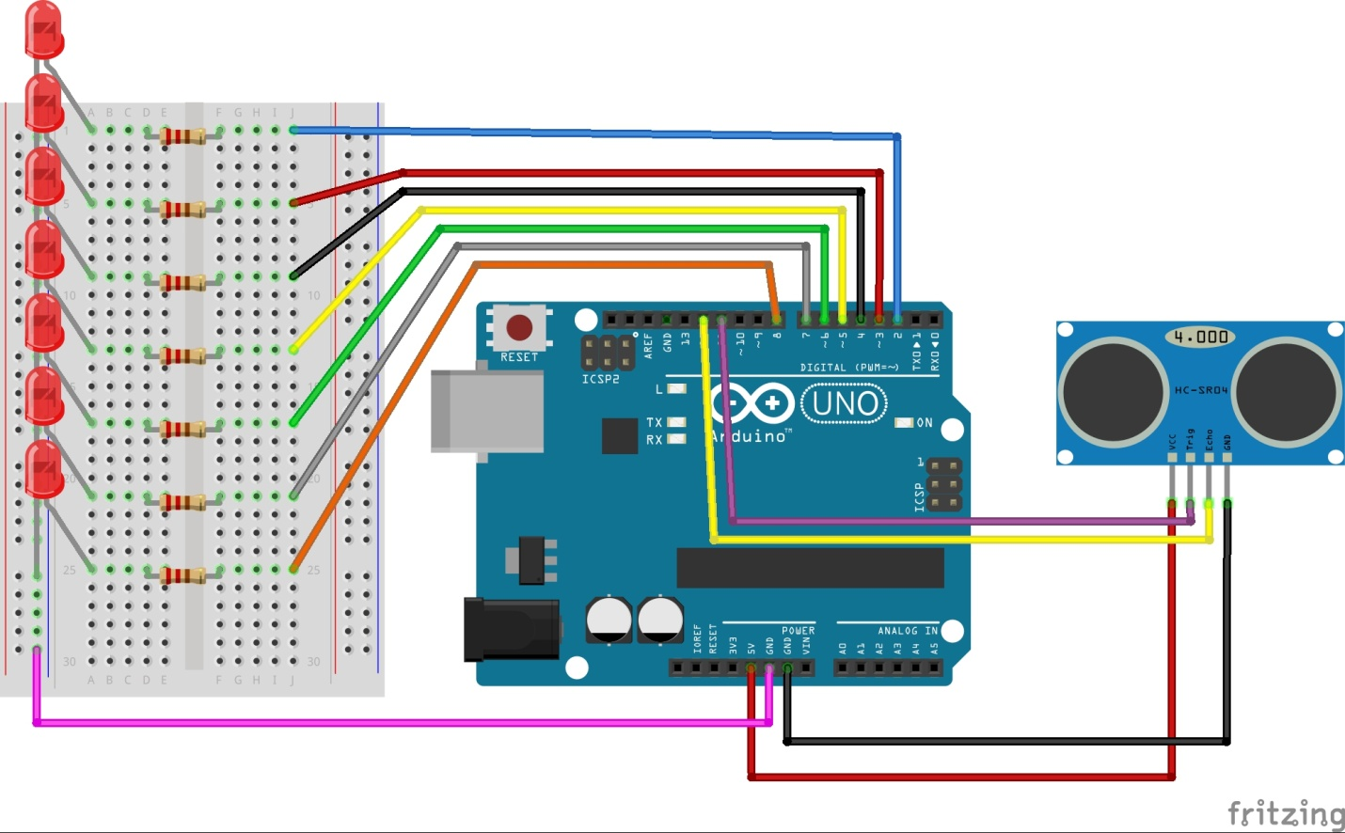

Result Image :

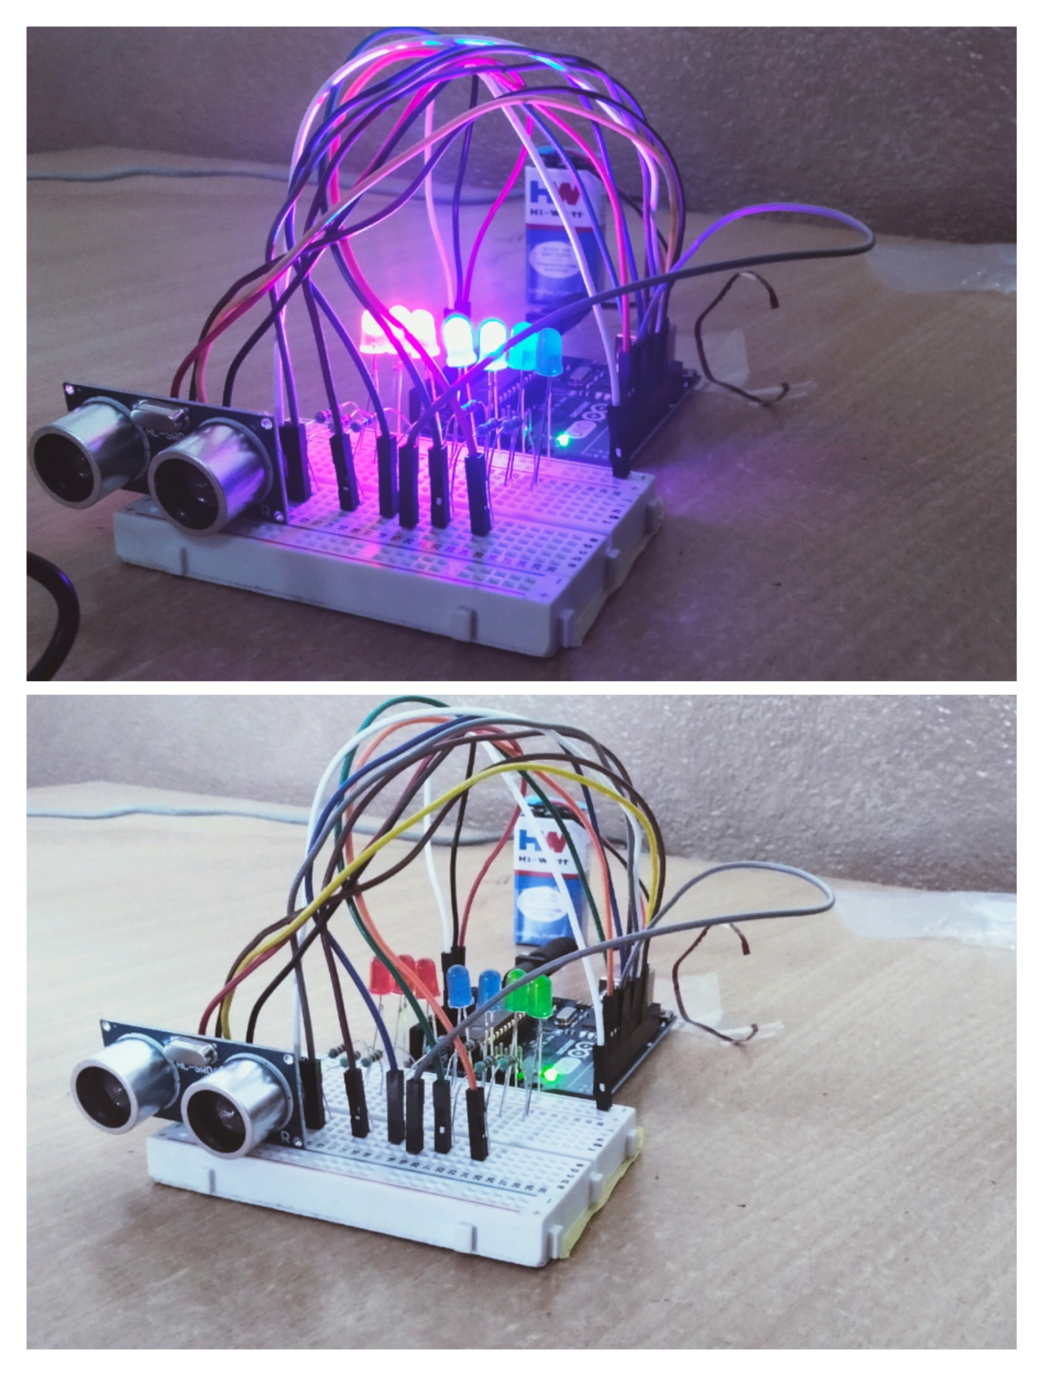

Code:

const int trig = 11;

const int echo = 12;

const int LED1 = 2;

const int LED2 = 3;

const int LED3 = 4;

const int LED4 = 5;

const int LED5 = 6;

const int LED6 = 7;

const int LED7 = 8;

int duration = 0;

int distance = 0;

void setup()

{

pinMode(trig , OUTPUT);

pinMode(echo , INPUT);

pinMode(LED1 , OUTPUT);

pinMode(LED2 , OUTPUT);

pinMode(LED3 , OUTPUT);

pinMode(LED4 , OUTPUT);

pinMode(LED5 , OUTPUT);

pinMode(LED6 , OUTPUT);

pinMode(LED7 , OUTPUT);

Serial.begin(9600);

}

void loop()

{

digitalWrite(trig , HIGH);

delayMicroseconds(1000);

digitalWrite(trig , LOW);

duration = pulseIn(echo , HIGH);

distance = (duration/2) / 28.5 ;

Serial.println(distance);

if ( distance <= 5 )

{

digitalWrite(LED1, HIGH);

}

else

{

digitalWrite(LED1, LOW);

}

if ( distance <= 7 )

{

digitalWrite(LED2, HIGH);

}

else

{

digitalWrite(LED2, LOW);

}

if ( distance <= 10 )

{

digitalWrite(LED3, HIGH);

}

else

{

digitalWrite(LED3, LOW);

}

if ( distance <= 15 )

{

digitalWrite(LED4, HIGH);

}

else

{

digitalWrite(LED4, LOW);

}

if ( distance <= 17 )

{

digitalWrite(LED5, HIGH);

}

else

{

digitalWrite(LED5, LOW);

}

if ( distance <= 20 )

{

digitalWrite(LED6, HIGH);

}

else

{

digitalWrite(LED6, LOW);

}

if ( distance <= 25 )

{

digitalWrite(LED7, HIGH);

}

else

{

digitalWrite(LED7, LOW);

}

}

Conclusion: Thus larn about arduino programming and project devlapment.

Name of group members :

* Rohit Jadhav
* Sanket Bhabar
* Premkumar kadam